Congratulations on your pregnancy

What to do now?
Please fill in the form attached and hand back in to Surgery.
You will need to ring the booking number as below

0151 247 4747 (Lines open 8.30am to 6pm Monday-Friday)

You will be seen for your first booking at either
- Local Community Midwife Centres
- Aintree Hospital (9am and 10.30am appointment)
- Women Hospital (9am, 10.30am, 1.30pm, 3pm, 6.30pm)

Alternatively, you can submit an online form to the Womens Hospital by this link which is also on our website www.stopgatelanemedicalcentre.co.uk (Women’s hospital will then get in touch with you within 24 hours to arrange a suitable first booking appointment) https://www.liverpoolwomens.nhs.uk/our-services/maternity/just-found-out-you-re-pregnant/pregnancy-booking-form/

After that you will be seen at the surgery by our Midwife Julie Hulse at 16 weeks and 26 weeks pregnant.

If you have any illness or on medication you will be contacted by the GP within 24 hours to discuss any medication or actions that may need to be taken.
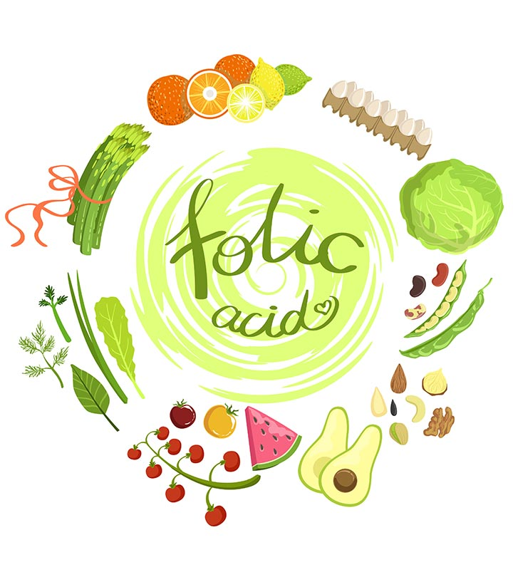
In the meantime please do take folic acid once daily available over the counter at the chemist. We are happy to prescribe this if you let us know on the form below.

Please be aware that you are entitled to a flu jab at any stage of the pregnancy if it coincides with the flu season and the practice can book this in for you. Please ask at reception.

If you are on any medication including anti-depressants it would be worthwhile looking at information on this website where you can submit the medication you are on and evidence based advice will be presented for you to read on a fact sheet for the drug and the GP will discuss this with you

www.mothertobaby.org

Early Pregnancy Questionnaire
(please hand in to reception once completed)

Name
Telephone number
Email address
Smoking Status
How much alcohol do you drink a week
Is this your first pregnancy? If not have you had any problems in your previous pregnancy?
Any concerns you have about your pregnancy you would like to discuss with the GP
Do you want the practice to prescribe you Folic acid or are you taking it already?
Do you think you are up to date in your own vaccinations?

